Dear students,

You can download the CIVIS-European University Alliance Application Form for Erasmus+ Studies 2021-22 from the webpage: <http://en.interel.uoa.gr/civis/civis-erasmus-mobility.html>

**Attention:** You should use Adobe Reader (latest version) to complete and save the application file.

**Do not use:** MAC, Tablet, ipad, smart phone or other PDF readers as Foxit or Nitro.

**STEP 1: Download the blank On line Application Form on your computer**

By using the above link a form will open in which you will be prompted to select “**I agree”** (This form is about the student consent upon the use of personal information by the Department of European and International Relations).

By pressing OK you will select: Download a blank application form for Studies: and a form will open (as Table 1 below) where you will be asked to fill in (**in ENGLISH with CAPITAL LETTERS**):

a) the Department at which you will be registered at NKUA,

b) your Last name,

c) your First name,

d) your current email address,

e) the Security Code that the system suggests every time.

**Table 1.**

Εικόνα που περιέχει στιγμιότυπο οθόνης

Περιγραφή που δημιουργήθηκε αυτόματα

As soon as you press the OK button a new form (as Table 2 below) will appear via which you will be able to download the **blank on line Application Form**.

**Table 2.**

Εικόνα που περιέχει στιγμιότυπο οθόνης

Περιγραφή που δημιουργήθηκε αυτόματα

**STEP 2: Fill in the on line Application Form**

Go to paragraph **Download a blank application (for Studies)** and Download the Application Form on your computer in order to complete and submit the document. The file should be saved with the name: Application Form_Studies_Last Name (e.g. Application Form_Studies_Velliniati).

1. **Personal Information**

* Your surname and name must be filled in in CAPITAL letters, in English and spelled exactly as in your passport/ID card. Your surname and name should be filled in, in the same way in all submitted documents (learning agreement, etc).

1. **Contact Information**

* Your email address should be correct (check the typing of your email address). All announcements and information are sent via email. It is the responsibility of each student to check emails regularly.

In case your email address on the application differs from the one on the nomination form from your Home University, please indicate which one will be used for our correspondence.

1. **Academic Information**

* Fill in the data of your **Home University** (name, erasmus code, etc).
* Fill in the Department and Supervisor at the **Receiving University** (you will find this information on our welcome email that you have already received)

**STEP 3: CHECK THE DATA and SAVE THE APPLICATION FORM**

**Go through the Application Form once again and check if everything is correct.**

1. Press the **CHECK** button, after the completion of the Application. If a field is not completed or has been filled in a wrong way it will appear colored in red, indicating that you should correct your input.
2. Press the **CONFIRM** button once you have checked carefully all your inputs and the application is correct. In this way the application will be finalized.

* Please ensure that by pressing the CONFIRM button the **VALIDATION NUMBER** (**a unique code number**) has been given to your application (You can see the unique code, in the box at the top of the form, left to the SAVE button).

1. When this action has been completed, press the **SAVE** button for the last time before your send your form.

**STEP 4: SUBMIT THE REQUIRED DOCUMENTS**

1. In order to upload the Application Form and the other required documents you have to use again the same URL address as you did at the beginning of the procedure: <http://en.interel.uoa.gr/civis/civis-erasmus-mobility.html>
2. You will see the same form as in Table 1, where you will have to fill in again your Department, your Last Name, your First Name and the code that the system requires. After pressing the OK button a form (as in Table 2) will open.
3. This time, you will follow the procedure “**UPLOAD YOUR COMPLETED APPLICATION (FOR STUDIES)**”.

* Please choose the button **BROWSE** in order to trace and choose your saved documents. The documents that must be submitted are explained in detail. **All documents must be in pdf format** (otherwise they will be rejected). The first document in the list must be your Application Form (filled-in and saved in STEP 3).
* Do not forget to type the **VALIDATION NUMBER** of the Application Form.
* If your Transcript of Records has not been issued yet, please contact [gexintav@uoa.gr](mailto:gexintav@uoa.gr).
* Then choose the button **UPLOAD** in order to upload the documents to our system.

During the uploading process please **do not close** the browser until the process is complete. You will consider that you have completed the submission of the on line Application Form only when you will see on your computer the following form:

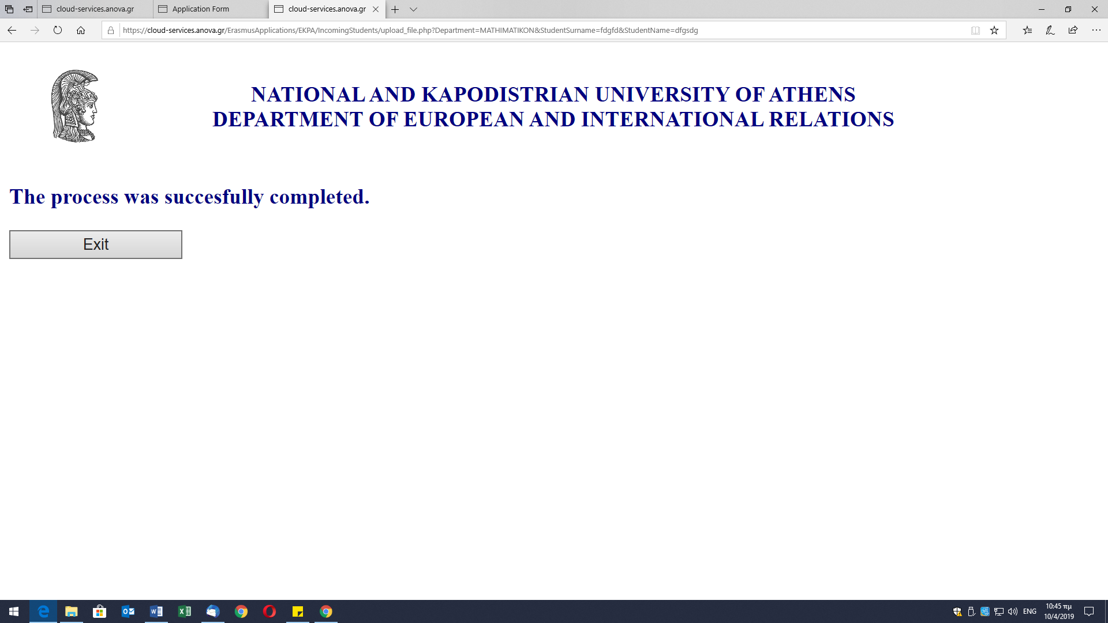

At this point you will press the button **EXIT** and you will complete the whole procedure.

Thank you for your cooperation.