Dear students,

In order to download the Application Form you can use the following URL address: http://cloud-services.anova.gr/ErasmusApplications/EKPA/IncomingStudents_Traineeship_2019/

Attention: You should use Adobe Reader, version 8.5 or newer to complete and save the application file. Do not use MAC, Tablet, ipad, smart phone or other PDF readers as Foxit or Nitro.

STEP 1: The Procedure in order to download the blank on line Application
Form on your computer

By using the above links a form will open (as Table 1 below) where you will be asked to fill in a) the Faculty at which you will be registered at UoA, b) your Last name, c) your First name, d) your current email address, e) the security code that the system suggest every time. (Fill in the fields in ENGLISH with CAPITAL LETTERS).

Table 1.
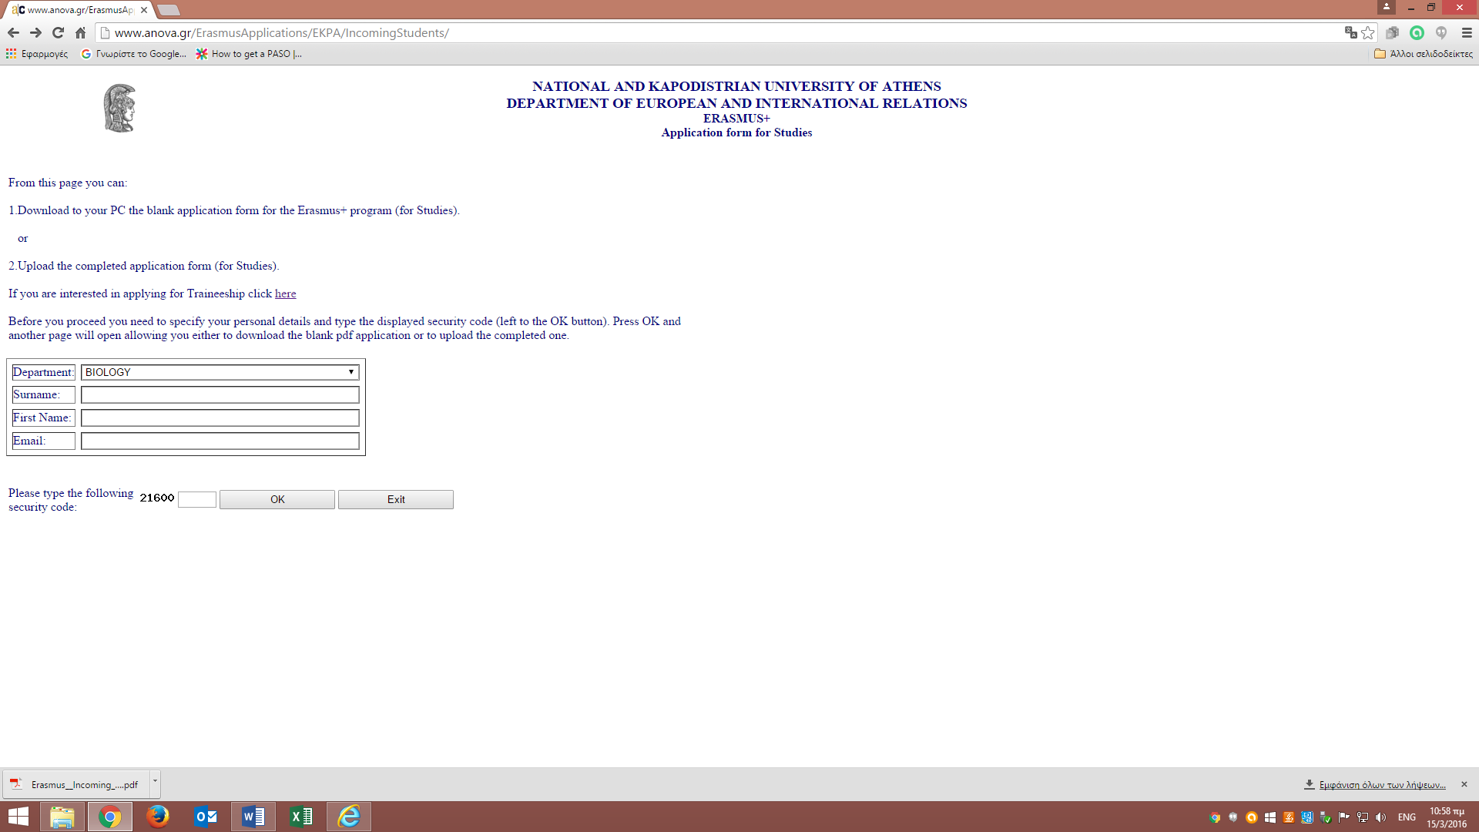

As soon as you press the OK button a new form (as Table 2 below) will appear via which you will be able to download the blank on line Application Form.

Table 2.
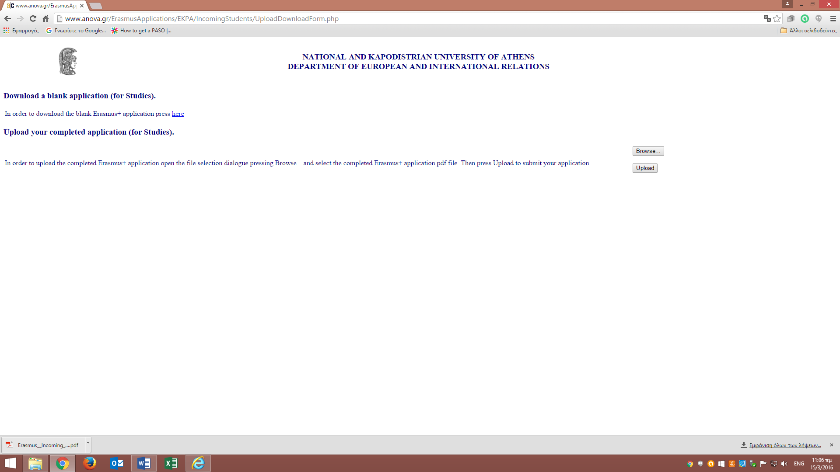
Following the given instructions on the form in order to download the blank Erasmus+ application you should press on the link “here”.

STEP 2: Filling in the on line Application Form
- Save the Application Form on your computer in order to complete and submit the document. The file should be saved with the name: Application Form_Studies_Last Name (e.g. Application Form_Studies_Velliniati).

- Fill in all the blank fields in ENGLISH with CAPITAL LETTER.

- Press the CHECK button, after the completion of the Application. If a field is not completed or has been filled in a wrong way it will appear colored in red, indicating that you should correct your input. (Before you press the CHECK button make sure that the cursor is in the field Knowledge of other Languages).

- Press the CONFIRM button once you have checked carefully all your inputs and the application is correct. In this way the application will be finalized.

△ Please ensure that by pressing the CONFIRM button a unique code number has been given to your application (You can see the unique code, in the box at the top of the form, left to the SAVE button).

When this action has been completed, press the SAVE button for the last time before your send your form.
Attention: If a confirmation number does not appear on the top of your Application Form, it means that you did not fill in the document correctly, so please check again and fill in properly.

STEP 3: The Procedure in order to upload the on line Application Form on
your computer

In order to upload the Application Form you have to use again the same URL address as you did at the beginning of the procedure:
http://cloud-services.anova.gr/ErasmusApplications/EKPA/IncomingStudents_Traineeship/.
You will see the same form as in Table 1, where you will have to fill in again your Faculty, your Last Name, your First Name and the code that the system requires. After pressing the OK button a form (as in Table 2) will open.
This time, you will follow the procedure “UPLOAD YOUR COMPLETED APPLICATION (FOR TRAINEESHIP)”. Please choose the button BROWSE in order to trace and choose your saved Application form. Then choose the button UPLOAD in order to upload the document to our system.
You will consider that you have completed the submission of the on line Application Form only when you will see on your computer the following form:

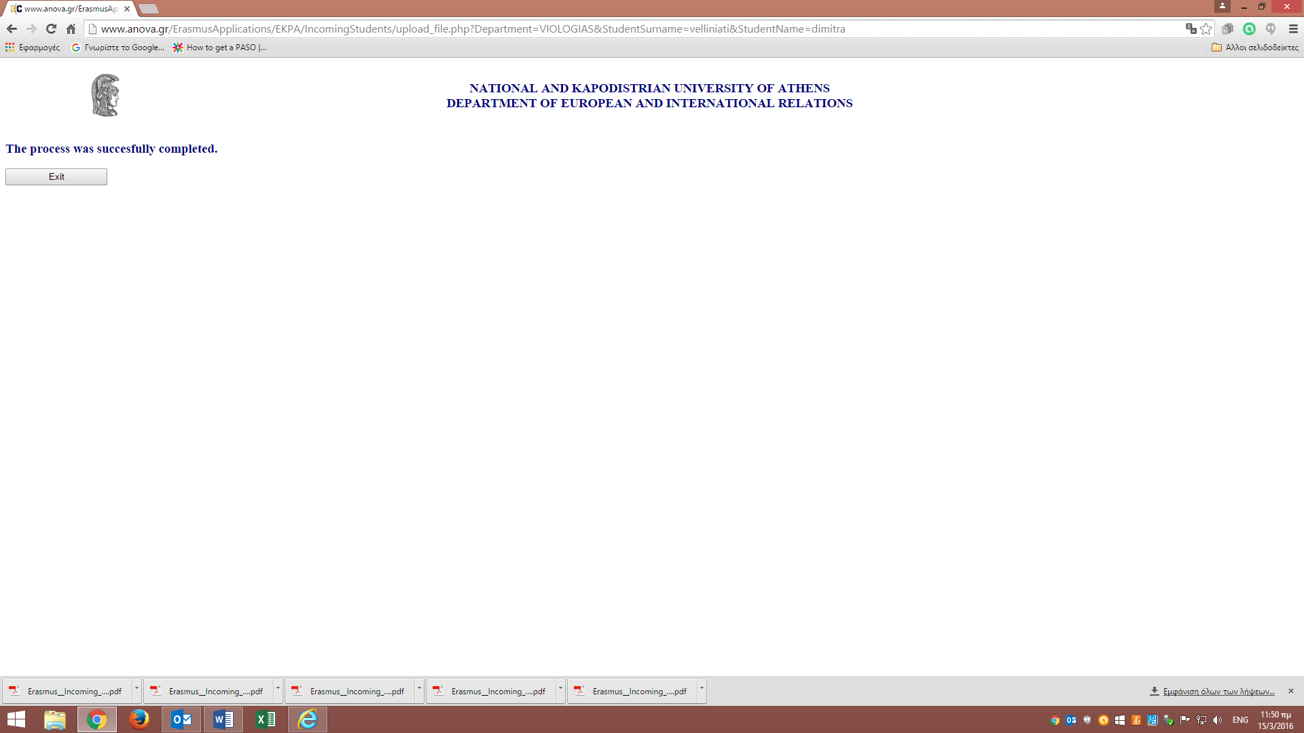

At this point you will press the button EXIT and you will complete the whole procedure.

