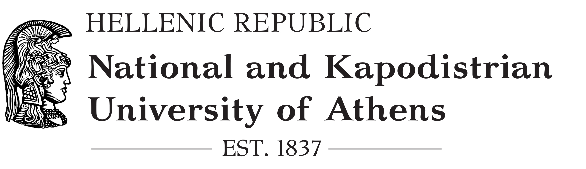
SPECIAL ACCOUNT FOR RESEARCH GRANTS
Financial and Administrative Support Unit
Individual’s declaration of personal details

Surname
Name
Father’s full name
Mother’s full name
Identity Card number or Passport number
Taxpayer’s identification Number /Tax Office
Home address
Street – Number
City
Post Code
Contact Number
Home
Work
Mobile
E-mail
Greek bank IBAN account
Foreign Bank IBAN account
Bank's name
Swift/BIC

In case that the beneficiary does not have a contract with the Financial and Administrative Support Unit of ELKE please additionally fill in the following fields:

Social Security/Health Insurance number
S.S.I. or N.R.S.I. number (for registered members only)
Professional capacity

I declare that I have been informed and I accept that:
- The entitled amount payable from SARG/UOA will be deposited to the above bank account.
- In case any of the above details will change, I will promptly inform SARG/UOA in writing by submitting the document Ε-ΔΠ-04-Ε16 «Changes to the beneficiary's personal information».
- I will provide bank documentation declaring that I am the main holder of the above bank account.

The declarant

(full name/signature)

Information on the processing of your personal data

The legal entity under Public Law, entitled “National and Kapodistrian University of Athens / Special Account for Research Grants” bears the responsibility for processing the personal data you are providing in this statement.
The aforementioned data are processed exclusively for the execution of a contract concluded between the NKUA/SARG and the declarant. This data is accessed exclusively by NKUA/SARG’s competent employees.
In addition to NKUA/SARG, recipients of the aforementioned data may also be other administrative or judicial authorities when it is either required by law or a relevant court decision, while they may additionally be natural persons or legal entities with whom NKUA/SARG cooperates for the storage and processing of the data (processors), such as software support and data storage companies. These entities are obliged by NKUA/SARG to comply with the terms and specifications set by the General Data Protection Regulation (EU) 2016/679.
Legal basis for the processing of the aforementioned personal data is the execution of a contract to which you as the subject of this data are a party. As long as NKUA/SARG holds and processes your personal data, you have the following rights:
- The right of access. [You can at any time be informed by us about which personal data we hold, and have access to.]
- The right to rectification. [If your personal data is inaccurate, you have the right to have the data rectified, without undue delay. If your personal data is incomplete, you have the right to have data completed.]
- The "right to be forgotten" [Unless we are required by law to maintain the data related to you, you may ask we delete it.]
- The right to data portability. [You may request that we transfer your data to another entity.]
- The right to restriction of processing. [In case you are in disagreement with the way we process your personal data you can request the halting or restriction of processing.]
- The right to object. [ You have the right to revoke your consent to the processing of your data at any time.]
In order to exercise your aforementioned rights you can contact our Data Protection Officer, Mrs. Nadia Liapi (email: dpo[at]uoa.gr), while in case your request was not satisfied you can file a complaint before the Personal Data Protection Authority.

Please fill in if you wish to be informed by e-mail from SARG about the deposition of your payment.
This field is filled in if the beneficiary's bank is not Greek
This field is filled in if the beneficiary's bank is not Greek
This field is filled in if the beneficiary's bank is not Greek
Refer to the capacity for which the beneficiary is paid for their services

