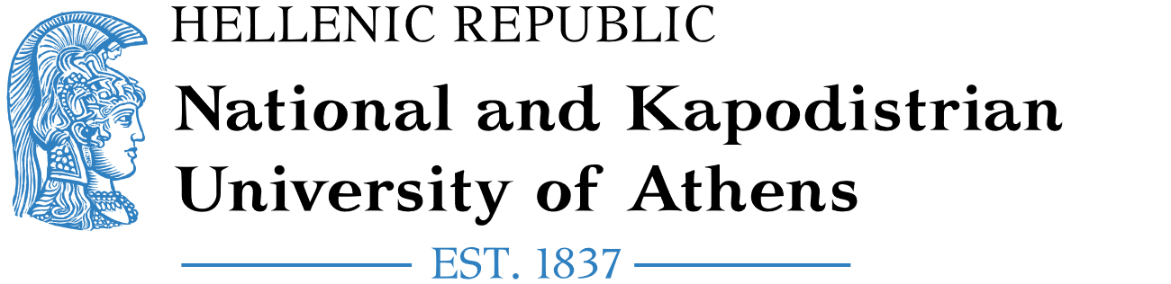**Εικόνα που περιέχει γραμματοσειρά, σύμβολο, Μπελ ηλεκτρίκ, στιγμιότυπο οθόνης

Περιγραφή που δημιουργήθηκε αυτόματα**

Erasmus+/KA171 International Mobility of **Staff for Training**

**Certificate of Training**

|  |
| --- |
| Name of the staff member:  Sending Institution:  Erasmus Code (if applicable):  Receiving Institution: **National and Kapodistrian University of Athens**  Erasmus Code: **G ATHINE01**  Academic year**:**  Number of training days (min. 5 days):  Number of training hours: (min. 8 hours per week): **8**  From:  To: |

|  |
| --- |
| **CONTENT OF THE TRAINING PROGRAMME:** |

Name of the Signatory:

Position of the Signatory:

Date:

Stamp:

Sign: